47th National Chemistry Olympiad

Utrecht University

PRACTICAL TEST

Marking Scheme

Tuesday 9th June 2026


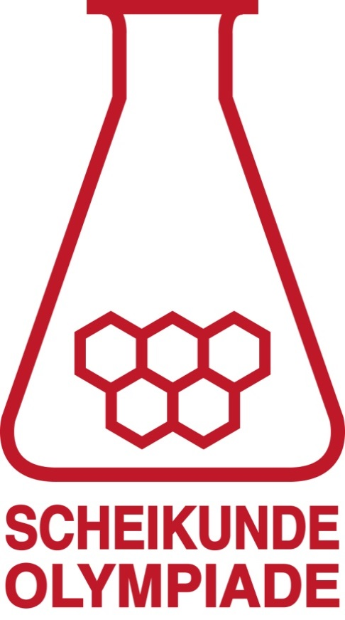



- The synthesis of the ester 1-pentylpropanoate 40 points
Maximum score 10
The following practical skills are assessed:
- safety, neatness and independent working
- handling of glassware
Maximum score 5
Assessment of 1-pentylpropanoate yield:
The score for yield is determined by comparing the yield (calculated by the organization) with the yield of an experiment carried out by the organization.
Maximum score 5
Assessment of 1-pentylpropanoate purity:
The purity of the product is determined by using an NMR spectrum.
The score is determined by comparing the measured purity with a completely pure sample. Optionally, an IR spectrum is also recorded.
- Maximum score 3
- propanoyl chloride 2
- triethylammonium chloride 1
Note:
If the answer „propanoic acid, hydrogen chloride and triethylammonium chloride” is given, count this as correct.
- Maximum score 1
Sulphuric acid reacts with the excess triethylamine (to triethylammonium chloride, which is thus removed from the reaction mixture)
- Maximum score 1
Magnesium sulphate is a desiccant, and that ensures that the last bit of water is removed.
- Maximum score 2
- number of mL stated 1
- correct accuracy 1
- Maximum score 4
- calculation of the number of grams of alcohol and acid chloride 1
- calculation of the number of moles of alcohol and acid chloride 1
- determining the maximum number of moles of ester that can be formed 1
- calculation of the maximum number of grams of ester that can be formed 1
- Maximum score 3
- masses noted 1
- correct units 1
- correct accuracy 1
- Maximum score 2
- yield calculated in grams 1
- percentage yield calculated 1
- Maximum score 4
An example of a correct answer is:
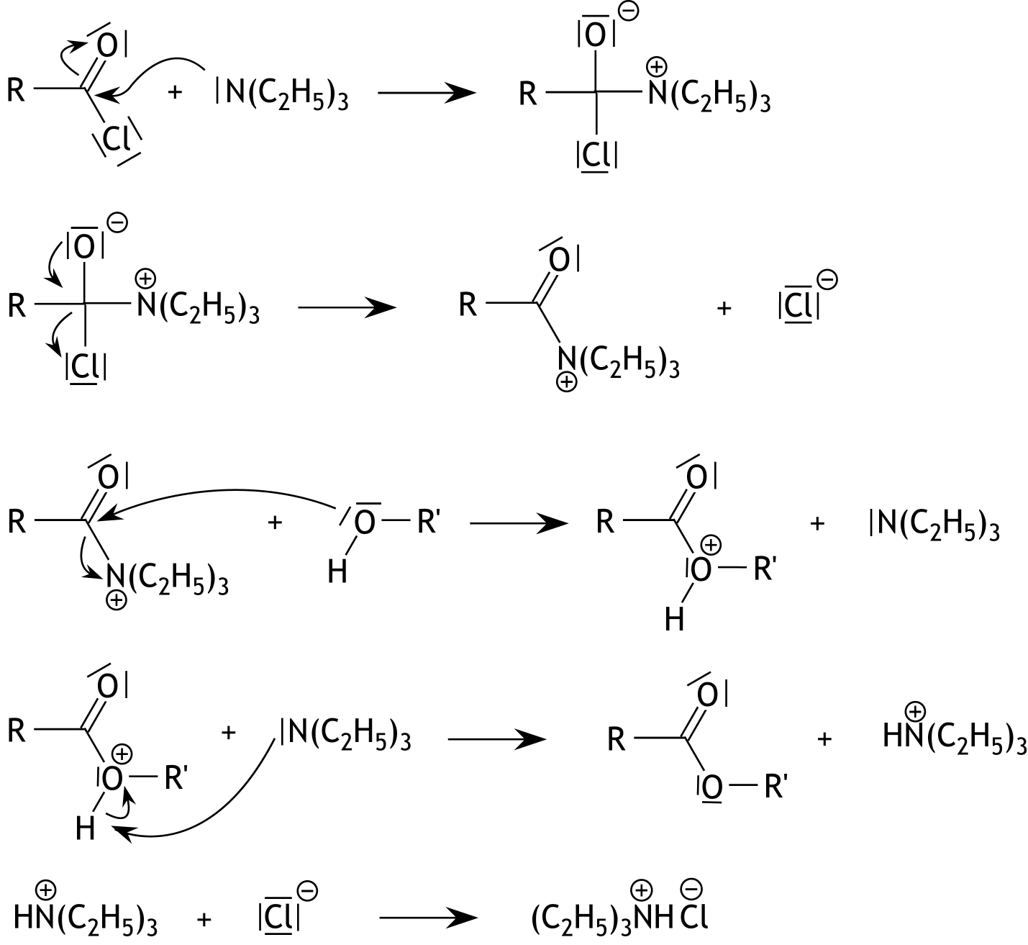

- a plausible mechanism drawn 1
- in each step all non-bonding electron pairs drawn 1
- in every step the charges in the correct place 1
- in every step all curly arrows drawn correctly 1
Note:
If the last step is not listed, do not penalize.

- The determination of the acetic acid content in vinegar using
a titration curve. 40 points
Maximum score 10
The following practical skills are assessed:
- safety, neatness and independent working
- handling of the glassware
- Maximum score 0
correct molarity stated
- Maximum score 7
- total number of mL sodium hydroxide correctly recorded 1
- corresponding pH values 1
- the second titration performed more efficiently than the first 5
- Maximum score 5
- grid optimally used 1
- title vertical axis 1
- title horizontal axis 1
- points displayed correctly 1
- smooth line drawn 1
Note:
If one or more of the above sub-scores are not met in the titration curve for the first titration, do not penalize this.
- Maximum score 10
- equivalence point correctly determined 1
- calculation of the number of mmol sodium hydroxide and the number of mmol acetic acid
in 5.00 mL vinegar 1
- calculation of the number of mg of acetic acid in 5.00 mL of vinegar 1
- calculation of the mass of 5.00 mL vinegar 1
- calculation of the mass percentage and conclusion 1
- result 5
- Maximum score 2
Examples of a correct answer are:
The use of a volumetric pipette is not necessary, because the 20 mL of water play no role in the calculation.
And
The use of a volumetric pipette is not necessary, because only the amount of acetic acid in the 5.00 mL of vinegar is important.
- correct explanation 1
- corresponding conclusion 1
- Maximum score 6
An example of a correct answer is:
After adding 5.0 mL of sodium hydroxide, half the number of moles of acetic acid is converted to acetate. Then a buffer solution is formed in which [HAc] = [Ac —], so .
At the equivalence point, a 0.050 M solution of sodium acetate was formed. In this . This gives [OH —] = 5.4·10^{—6} mol L^{—1},
so pH = 14.00 — (—log5.4·10^{—6}) = 8.73.
- after adding 5.0 mL of sodium hydroxide solution, [HAc] = [Ac—] 1
- calculation of the pH of the solution after adding 5.0 mL sodium hydroxide 1
- at the equivalence point a 0.050 M solution of sodium acetate was formed 1
- notion that [HAc] = [OH—] and [Ac—] = 0.050 — [OH—] 1
- calculation of the [OH—] in the solution formed at the equivalence point 1
- calculation of the pH in the solution formed at the equivalence point 1
Note:
If [OH—] is neglected compared to 0.050 in the calculation of the pH of the solution formed at the equivalence point, count this as correct.

